Savitribai Phule Pune University
Smt. Kashibai Navale College of Engineering, Pune
Student Development Section (2019-20)
Tree Plantation Report
In academic year 2019-20 STES’s, Smt. Kashibai Navale College of Engineering, Pune organized various activities for tree plantation. The details of activities is as follows,
- Tree Plantation on Taljai Pathar and Sinhgad Fort / Ghats
SKNCOE has successfully conducted event of tree plantation on August 15, 2019 and September 15, 2019. The venue of the event was Talajai Pathar and Sinhgad Fort & Sinhgad Ghats, Pune respectively. 200 students and faculties supported the task with full enthusiasm and dynamism. Total 160 specimens planted on Talajai Pathar and the bay of Sinhgad Fort. The specimens were mainly of Neem, Bahava, Arjun, Mango, Peepal. Movement was carried out with great courtesy and proper organization. This activity was performed with the help of gardening instruments.

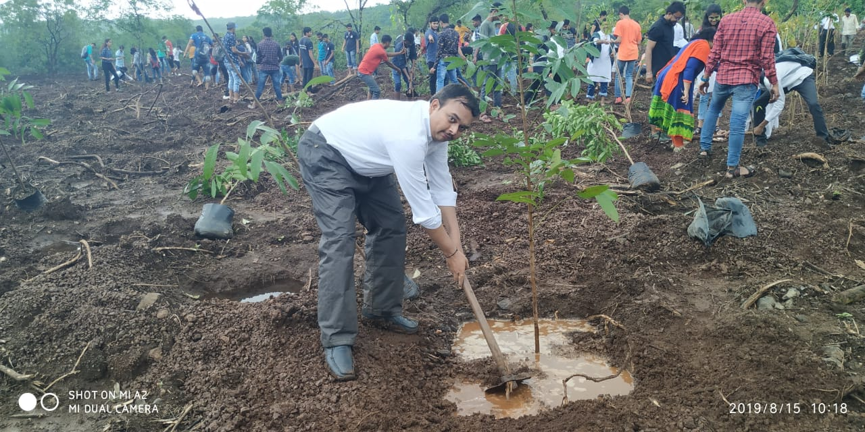 | 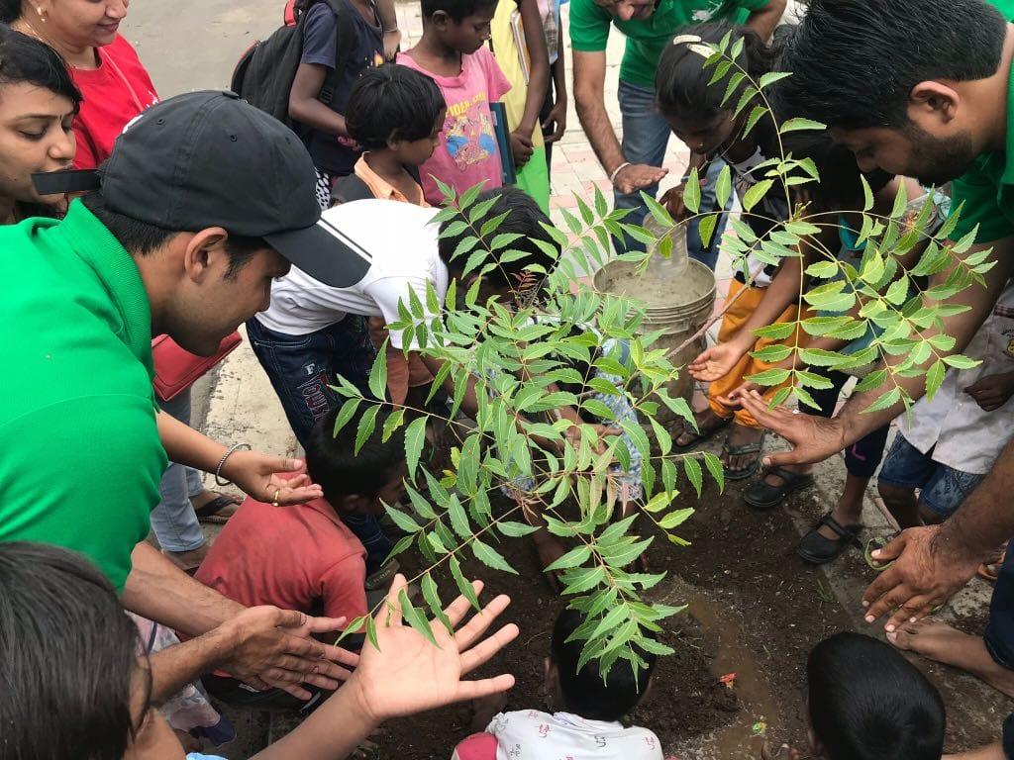
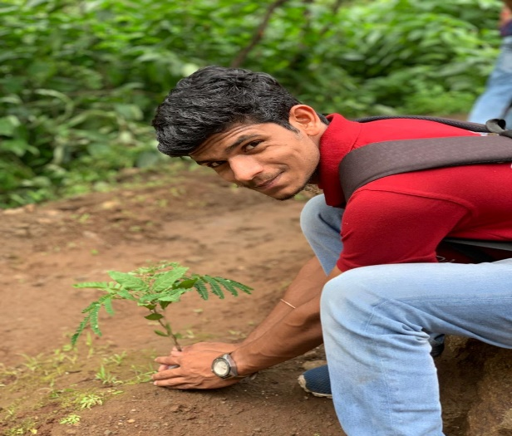 | 